PROJECT REPORT
Predictive Maintenance Analytics
Python | SQL Server | Power BI
Prepared by: Rahul Santosh Mangale
Dataset: AI4I 2020 Predictive Maintenance (10,000 records)

1. Introduction
Unplanned machine breakdowns cause production delays, repair costs and safety risks. Predictive maintenance uses operating data to find the conditions under which machines fail, so that maintenance can be planned before a breakdown happens.
This project is an end-to-end data analytics solution on a machine failure dataset. It covers data cleaning and exploration in Python, business analysis in SQL Server, an interactive Power BI dashboard, and machine learning models that predict failures.

2. Problem Statement and Objectives
Problem: Machine failures are rare but costly, and it is not clear which operating conditions lead to them.
Objectives:
- Understand the dataset and check its quality.
- Measure the overall failure rate and compare it across machine types.
- Identify which failure modes are most common.
- Study how tool wear, rotational speed, torque, temperature and power affect failures.
- Build an interactive dashboard that gives a quick view of machine health.
- Build and compare machine learning models that predict whether a machine will fail.

3. Dataset Description
The dataset is the AI4I 2020 Predictive Maintenance dataset (ai4i2020.csv). It has 10,000 records and 14 columns, with no missing values and no duplicate rows.
Column | Description
UDI | Unique record number (1 to 10,000)
Product ID | Product identifier
Type | Product quality type: L (Low), M (Medium), H (High)
Air temperature [K] | Surrounding air temperature in Kelvin
Process temperature [K] | Process temperature in Kelvin
Rotational speed [rpm] | Rotational speed of the machine
Torque [Nm] | Torque applied, in Newton-metres
Tool wear [min] | Minutes of tool use
Machine failure | Target: 1 = failure, 0 = no failure
TWF, HDF, PWF, OSF, RNF | Failure modes: tool wear, heat dissipation, power, overstrain and random failure

4. Tools and Technologies
Tool | Purpose
Python (pandas, NumPy, Matplotlib, Seaborn, scikit-learn) in Jupyter Notebook | Data cleaning, exploration, feature engineering and machine learning
SQL Server (T-SQL) | Database storage, views and business analysis queries
Power BI | Interactive dashboard and KPI reporting

5. Project Workflow
- Load the data and understand its structure (Python).
- Run data quality checks (Python).
- Explore the data with statistics and charts (Python).
- Create new features (Python and SQL).
- Load the data into SQL Server and create analysis views.
- Answer business questions with SQL queries.
- Connect Power BI to the SQL view and build the dashboard.
- Train and compare machine learning models.
- Document findings and recommendations (this report).

6. Data Understanding and Cleaning (Python)
The dataset was loaded into a pandas DataFrame and checked with shape, info(), describe() and dtypes.
Data quality results:
- Shape: 10,000 rows and 14 columns.
- Missing values: none in any column.
- Duplicate rows: none.
- Data types: all correct (integers, floats and two text columns).
- Categorical values: Type has three values (L, M, H); Machine failure has two (0, 1).
Because the data was already clean, no rows needed to be removed or imputed.
Key statistics:
Variable | Mean | Min | Max
Air temperature [K] | 300.00 | 295.3 | 304.5
Process temperature [K] | 310.01 | 305.7 | 313.8
Rotational speed [rpm] | 1,538.8 | 1,168 | 2,886
Torque [Nm] | 39.99 | 3.8 | 76.6
Tool wear [min] | 107.95 | 0 | 253

7. Exploratory Data Analysis

7.1 Failure distribution
Out of 10,000 machines, 339 failed (3.39%) and 9,661 did not fail (96.61%). The data is highly imbalanced, which matters when evaluating models (see Section 11).
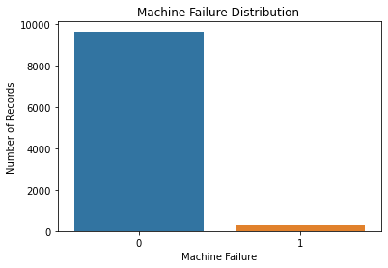

7.2 Machine type
The dataset has 6,000 Low (L), 2,997 Medium (M) and 1,003 High (H) quality machines. Lower-quality machines fail more often, and the failure rate falls steadily as quality improves.
Type | Machines | Failure rate
L (Low) | 6,000 | 3.92%
M (Medium) | 2,997 | 2.77%
H (High) | 1,003 | 2.09%
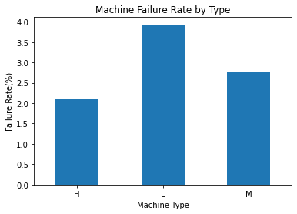

7.3 Failure modes
Failure modes are the different reasons a machine can fail. Each machine has five flags (TWF, HDF, PWF, OSF, RNF), set to 1 when that cause occurred.
Failure mode | Count
HDF: Heat Dissipation Failure | 115
OSF: Overstrain Failure | 98
PWF: Power Failure | 95
TWF: Tool Wear Failure | 46
RNF: Random Failure | 19

Heat dissipation, overstrain and power failures together account for most breakdowns. The mode counts add up to more than 339 because some machines fail in more than one way.
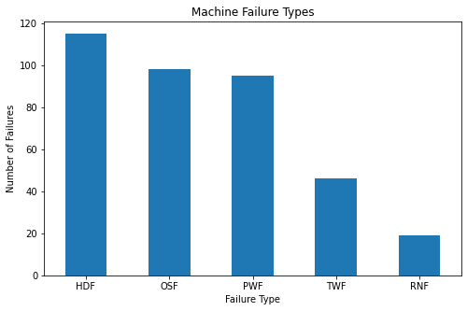

7.4 Distribution of operating variables
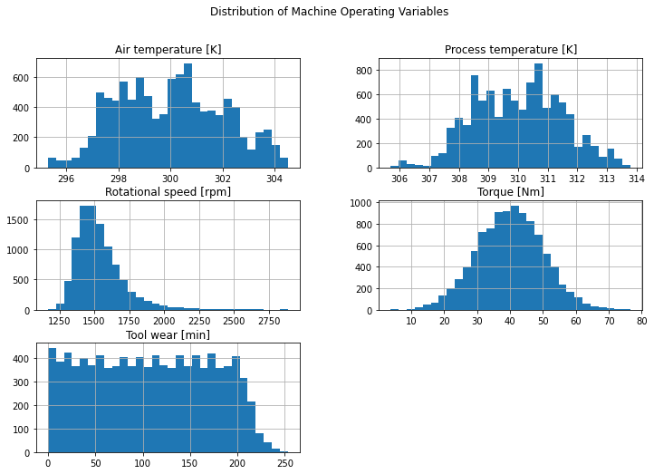

7.5 Operating variables versus failure (box plots)
Each box plot compares one variable between machines that did not fail (0) and machines that failed (1). The box covers the middle half of the values and the line inside it is the median.
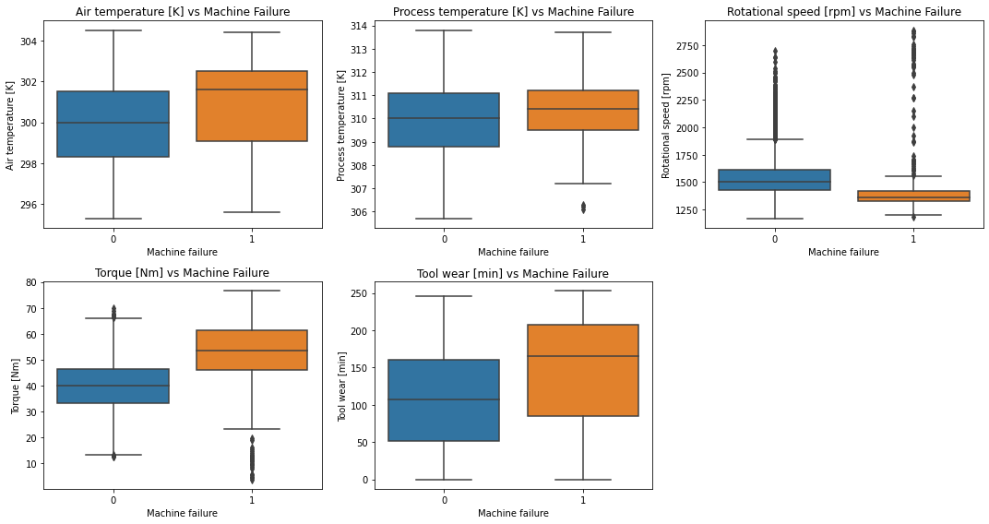

7.6 Correlation heatmap
The heatmap shows how strongly the variables move together, from -1 to +1. It is used to see which variables are most related to machine failure.
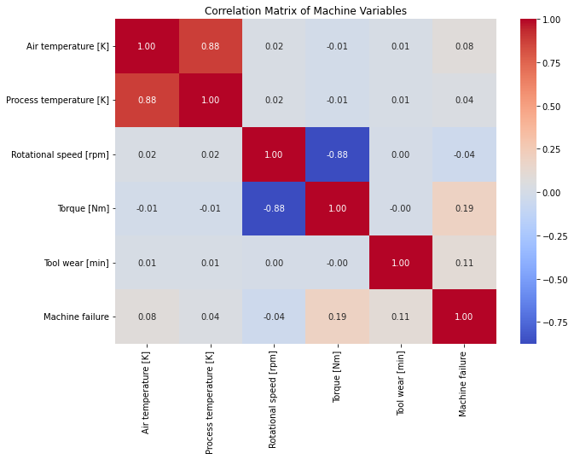

8. Feature Engineering
Three new features were created:
- Temperature Difference [K] = Process temperature minus Air temperature. It shows how much heat the process adds above the surroundings.
- Power Proxy = Rotational speed multiplied by Torque. It is a relative measure of mechanical load, not actual electrical power in watts.
- Tool Wear Category (Python): Low (0 to 100 min), Medium (101 to 200 min) and High (above 200 min), with 4,667, 4,571 and 762 machines.
Temperature Difference and Power Proxy were also created in SQL so that Power BI could use them.

9. SQL Server Analysis
The data was loaded into the database PredictiveMaintenanceDB as the table dbo.ai4i2020. Two views were then created:
- vw_MachineAnalysis: adds Temperature_Difference_K, Power_Proxy and a Failure_Status label (Failure or No Failure).
- vw_PowerBI_MachineAnalysis: the final view for Power BI. It adds Tool_Wear_Band (0-50, 51-100, 101-150, 151-200, 201+), Power_Band (Low below 50,000; Medium below 100,000; High above) and Failure_Type (the first matching failure mode, or No Failure).
The SQL queries below answer the business questions. Each query is followed by the screenshot of its output.

9.1 Checking the imported data
SELECT COUNT(*) AS TotalRows FROM dbo.ai4i2020;

SELECT TOP 10 * FROM dbo.ai4i2020;

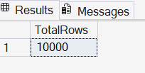

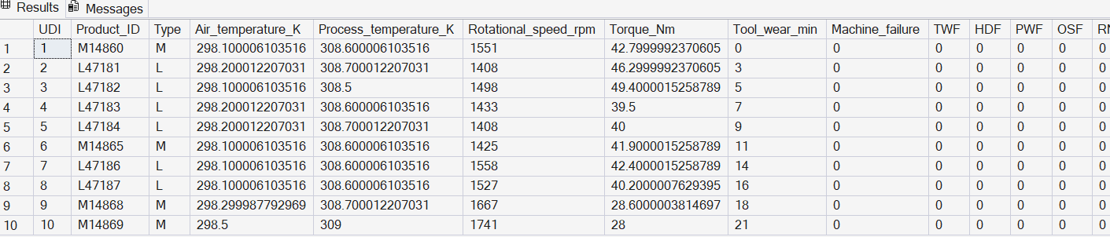

9.2 Creating the analysis views
CREATE VIEW vw_MachineAnalysis AS
SELECT UDI, Product_ID, Type, Air_temperature_k, Process_temperature_k,
Rotational_speed_rpm, Torque_Nm, Tool_wear_min, machine_failure,
TWF, HDF, PWF, OSF, RNF,
Process_temperature_k - Air_temperature_k AS Temperature_Difference_K,
Rotational_speed_rpm * Torque_Nm AS Power_Proxy,
CASE WHEN machine_failure = 1 THEN 'Failure' ELSE 'No Failure' END AS Failure_Status
FROM dbo.ai4i2020;

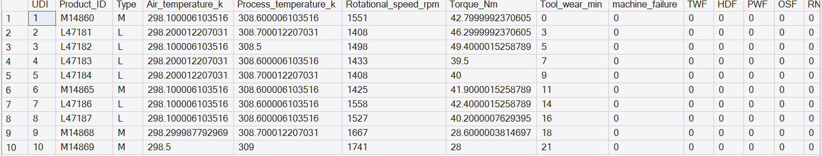

9.3 Overall failure KPIs
SELECT COUNT(*) AS Total_Machines,
SUM(machine_failure) AS Total_Failures,
CAST(SUM(machine_failure) * 100.0 / COUNT(*) AS DECIMAL(10,2)) AS Failure_Rate_Percent
FROM dbo.vw_MachineAnalysis;

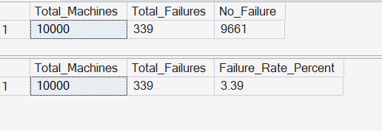

9.4 Failure by machine type
SELECT Type, COUNT(*) AS Total_Machines,
SUM(machine_failure) AS Total_Failures,
CAST(SUM(machine_failure) * 100.0 / COUNT(*) AS DECIMAL(10,2)) AS Failure_Rate_Percent
FROM dbo.vw_MachineAnalysis
GROUP BY Type ORDER BY Failure_Rate_Percent DESC;

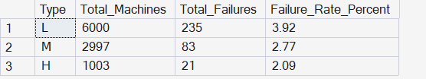

9.5 Failure type analysis
SELECT 'TWF - Tool Wear Failure' AS Failure_Type, SUM(TWF) AS Failure_Count FROM dbo.vw_MachineAnalysis
UNION ALL SELECT 'HDF - Heat Dissipation Failure', SUM(HDF) FROM dbo.vw_MachineAnalysis
UNION ALL SELECT 'PWF - Power Failure', SUM(PWF) FROM dbo.vw_MachineAnalysis
UNION ALL SELECT 'OSF - Overstrain Failure', SUM(OSF) FROM dbo.vw_MachineAnalysis
UNION ALL SELECT 'RNF - Random Failure', SUM(RNF) FROM dbo.vw_MachineAnalysis;

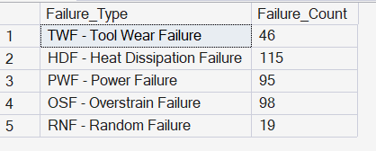

9.6 Tool wear analysis
Machines were grouped into tool wear bands (0-50, 51-100, 101-150, 151-200 and 201+ minutes) and the failure rate was calculated for each band.

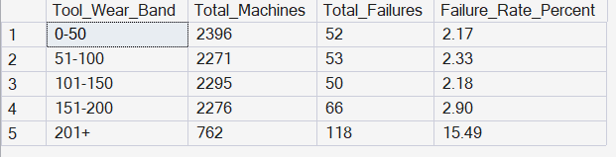

9.7 Rotational speed, torque and temperature
The average rotational speed, torque, Power Proxy, air temperature, process temperature and temperature difference were compared between failed and non-failed machines.

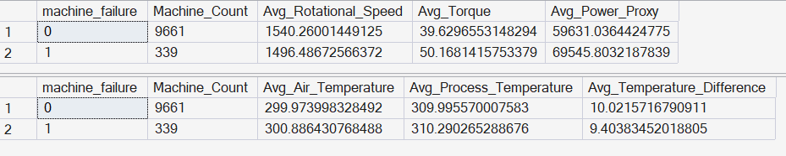

9.8 Power proxy analysis
Machines were grouped into Low (below 50,000), Medium (below 100,000) and High power bands, and the failure rate was calculated for each.

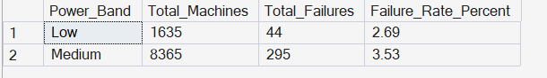

9.9 Final view for Power BI
vw_PowerBI_MachineAnalysis adds Tool_Wear_Band, Power_Band and Failure_Type to the first view. It was validated by checking the first 10 rows, the total row count (10,000) and the Failure_Status split.

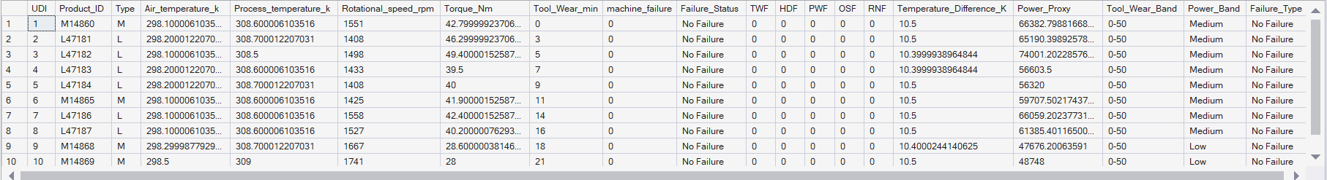

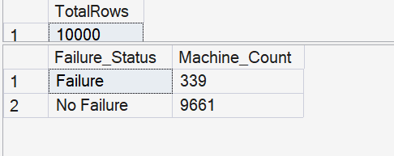

10. Power BI Dashboard
Power BI was connected to SQL Server and loaded vw_PowerBI_MachineAnalysis. The dashboard, titled Predictive Maintenance Dashboard, has these parts:
Visual | Purpose
KPI cards | Total Machines, Total Failures, Failure Rate and Average Tool Wear
Donut chart | Share of Failure vs No Failure
Column chart: Failure by Machine Type | Which machine types fail most
Column chart: Failures by Tool Wear Band | How failures change as tools wear
Bar chart: Failure Type Analysis | Which failure modes are most common
Scatter chart: Torque vs Rotational Speed | Operating conditions of failed and non-failed machines
Scatter chart: Temperature Analysis | Air and process temperature, coloured by failure status

The dashboard lets a maintenance manager see overall machine health at a glance and then look at the conditions behind failures.

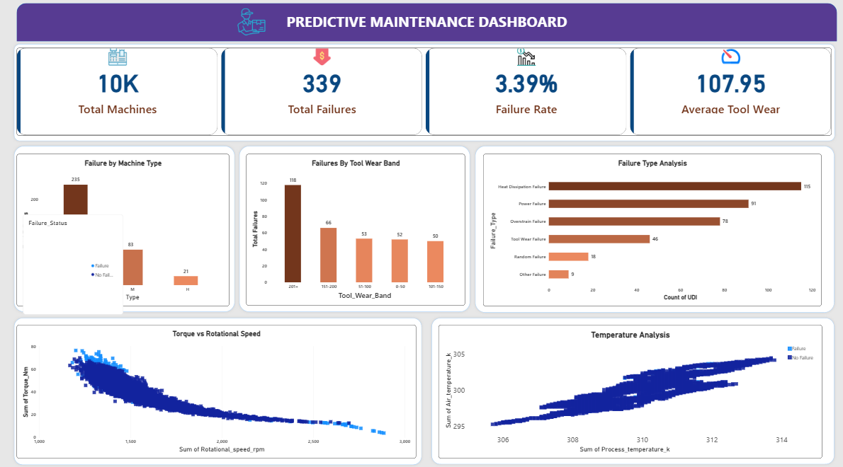

11. Machine Learning Models
The target was Machine failure. The inputs were Type (converted to numeric columns), air temperature, process temperature, rotational speed, torque, tool wear, Temperature Difference and Power Proxy. The data was split 80% for training (8,000 rows) and 20% for testing (2,000 rows), keeping the same failure ratio in both parts (stratified split, random_state = 42). The test set has 68 real failures and 1,932 non-failures.
Model | Accuracy | Precision | Recall | F1 score
Logistic Regression (scaled features) | 96.75% | 57.1% | 17.6% | 0.27
Decision Tree (max depth 5) | 98.50% | 97.5% | 57.4% | 0.72
Random Forest (200 trees, depth 10, balanced weights) | 98.90% | 92.6% | 73.5% | 0.82

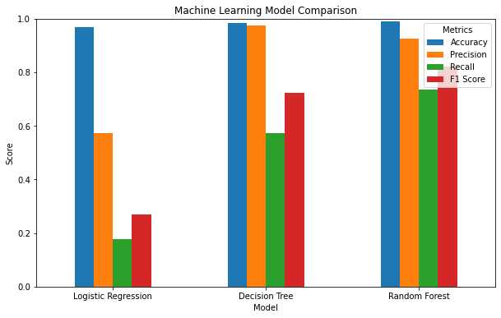
Why accuracy alone is misleading: only 3.4% of machines fail, so a model that always predicts "no failure" would already score about 96.6% accuracy. Recall (how many real failures the model catches) matters more here, because a missed failure is the costly mistake.
Result: The Random Forest is the best model. It caught about 50 of the 68 real failures in the test set and raised only about 4 false alarms. The Logistic Regression caught only about 12.
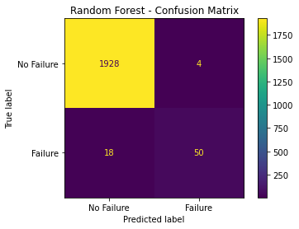

Feature importance (Random Forest)
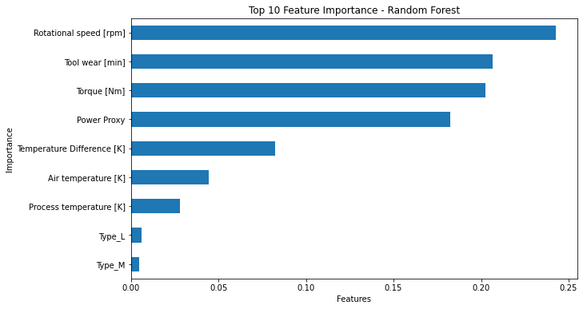

Feature | Importance
Rotational speed [rpm] | 24.3%
Tool wear [min] | 20.7%
Torque [Nm] | 20.3%
Power Proxy | 18.2%
Temperature Difference [K] | 8.2%
Air temperature [K] | 4.4%
Process temperature [K] | 2.8%
Type (L and M) | about 1.1% combined

Power Proxy and Temperature Difference, the features created in this project, together account for about 26% of the model's decisions. Rotational speed, tool wear, torque and power together account for about 85%, so mechanical load and tool condition are the main drivers of failure.
As a test, the model was given a sample machine (air 300 K, process 310 K, 1,500 rpm, torque 50 Nm, tool wear 100 min, Type M). It predicted no failure, with a failure probability of about 0.41%.

12. Key Findings
- The overall failure rate is 3.39% (339 of 10,000 machines).
- Failure rate rises as machine quality falls: 3.92% for Low, 2.77% for Medium and 2.09% for High type.
- Heat dissipation (115), overstrain (98) and power failures (95) are the most common failure modes.
- Rotational speed, tool wear, torque and power load are the most important factors in predicting failure.
- A Random Forest model can identify about 74% of failures on unseen data with high precision (93%), far better than Logistic Regression.

13. Recommendations
- Monitor machines with high rotational speed, high torque or high power load more closely, since these are the strongest warning signs.
- Plan tool replacement based on tool wear instead of waiting for failure.
- Pay extra attention to Low quality (L) type machines, which have the highest failure rate.
- Add cooling checks where the temperature difference is high, because heat dissipation is the most common failure mode.
- Use the Random Forest model as an early-warning tool to flag machines for inspection, and lower the prediction threshold if catching more failures matters more than avoiding false alarms.

14. Limitations and Future Work
- Imbalanced data: with only 339 failures, the model still misses about one in four. Techniques such as SMOTE, threshold tuning or cross-validation could improve recall.
- Single test split: results come from one 80/20 split; cross-validation would give a more reliable estimate.
- Synthetic data: this is a well-known public dataset created for learning and research, so results should be validated on real plant data before use in production.
- Proxy features: Power Proxy is a relative measure, not real power.
- Future work: try Gradient Boosting or XGBoost, tune hyperparameters, add time-series data, and deploy the model so that dashboard users can enter machine readings and get a failure probability.

15. Conclusion
This project covered the full analytics cycle: cleaning and exploring the data in Python, answering business questions in SQL Server, presenting the results in a Power BI dashboard, and building a machine learning model to predict failures. The analysis shows that tool wear and mechanical load are the key drivers of machine failure and that a Random Forest model can detect most failures in advance, which supports planning maintenance before breakdowns occur.

